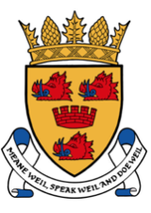

Cromarty & District Community Council

The next C&DCC meeting will be held on

Monday, 26th April 2021 at 7.30pm
Due to the Covid-19 crisis, all current C&DCC meetings are held virtually using the `Whereby` platform. The C&DCC has currently 3 vacant spaces for members of the public to attend this meeting.

If you would like to join us, please e/mail your request to: cromartydistrictcc@gmail.com
This will be on a first come first serve basis. We will then advise you of log in details and meeting protocol.
via Video Conferencing, due to Covid-19
If you would like anything to be discussed, please contact Paige Shepherd (Chair),
in advance of the meeting.

AGENDA

- Welcome and Apologies.
- Declaration of Interests
- Approval of previous minutes - 29 March 2021
- Matters Arising from previous minutes - 29 March 2021
- Youth Issues
- Treasurer's Report including Draft Financial Statements for the Year to 31st March 2021
- Victoria Hall Report including Youth Café
- Members' Reports
  - Portfolios
  - Highland Council – Seagull Nuisance and Weed Killing
  - Correspondence Received
- Any Other Business
- Date of Next Meeting and 2021 Annual General Meeting

www.cromartylive.co.uk

